Network Graphs with Tableau

[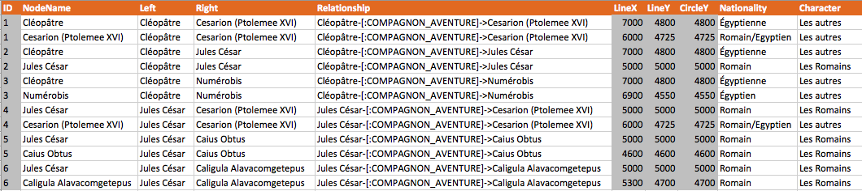](https://stephanefrechette.com/blog/wp-content/uploads/2014/04/tableau_ng_00.png)

Let’s quickly go through the steps and create a network graph with this very small sample dataset;

To start, drag the “LineY” attribute to the **Rows** shelf and the “LineX” attribute on the **Columns** shelf. Set the Mark type to “Circle” this will render a basic scatterplot.

[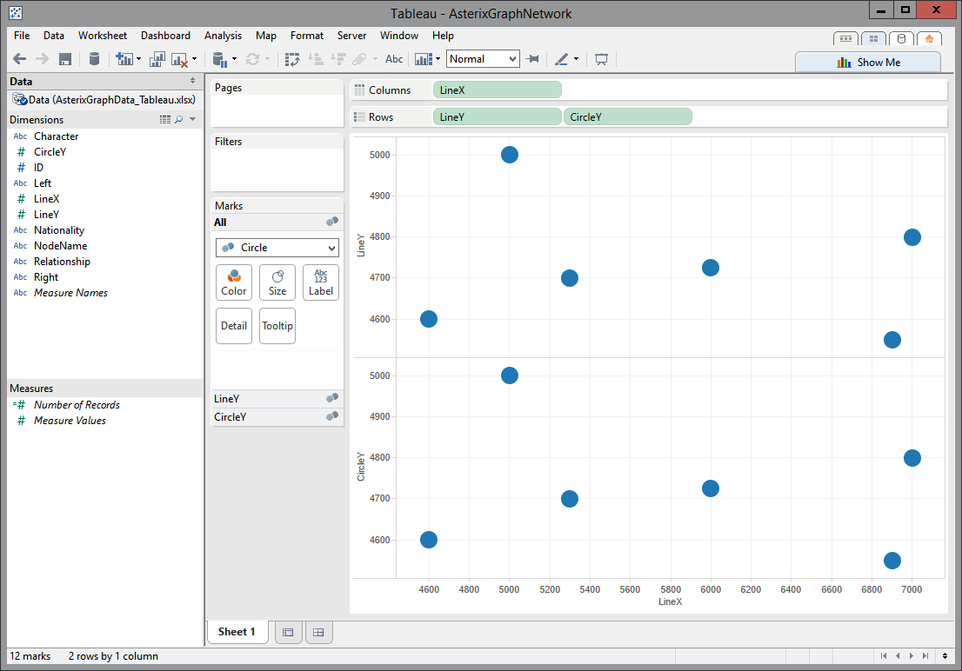](https://stephanefrechette.com/blog/wp-content/uploads/2014/04/tableau_ng_01.png)

Add the “CircleY” attribute to the **Rows** shelf as a Double Axis (right click on the Axis and click “Dual Axis”), and then synchronize the two Y axes (right click on the Axis, and click on “Synchronize Axis”)

[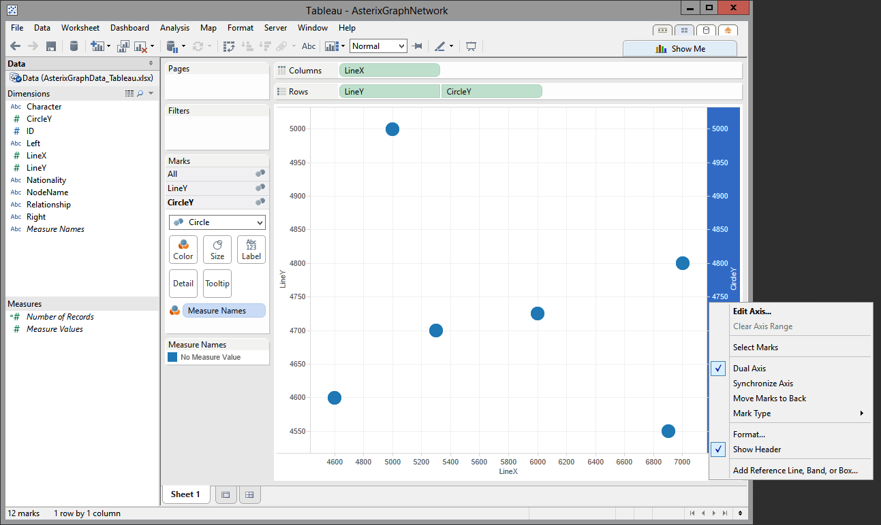](https://stephanefrechette.com/blog/wp-content/uploads/2014/04/tableau_ng_02.png)

Next we need to format the Tableau Mark cards to show “Multiple Mark Types“. Go to the “CircleY” Mark card and set Mark type as “Pie“. Drag the “NodeName” attribute on **Label** and “ID” on **Color** on the Mark card – each pie slice represents a connection (transaction)

[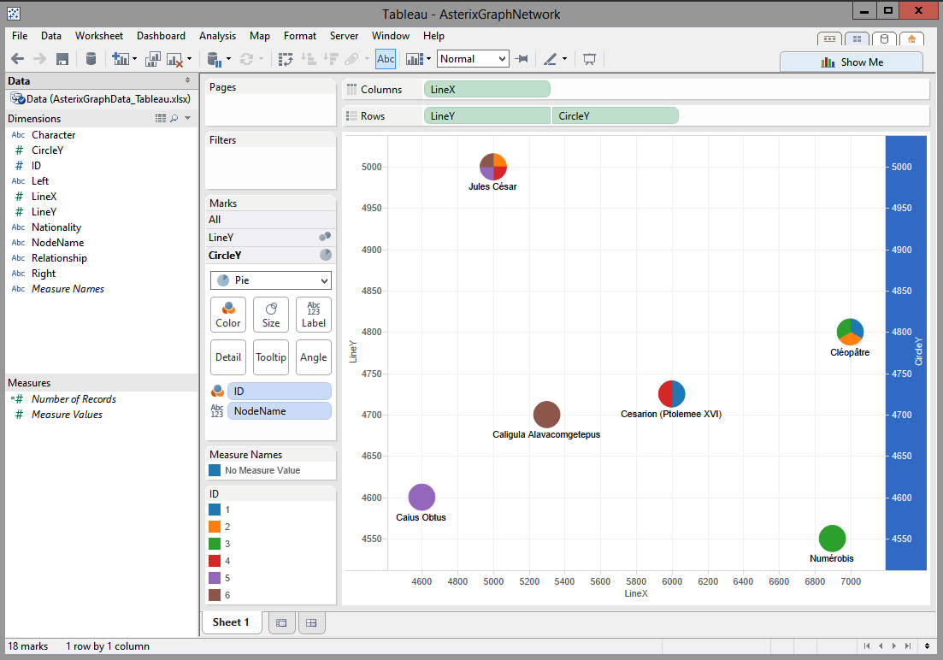](https://stephanefrechette.com/blog/wp-content/uploads/2014/04/tableau_ng_03.png)

Then cycle to the “LineY” Mark. Drag the “ID” and “Relationship” attributes on **Detail** on the Mark card. Set the Mark type to “Line”. Tableau will connect the dots… and Voilà! A simple Network Graph. You can resize the LineY series to make lines thinner.

[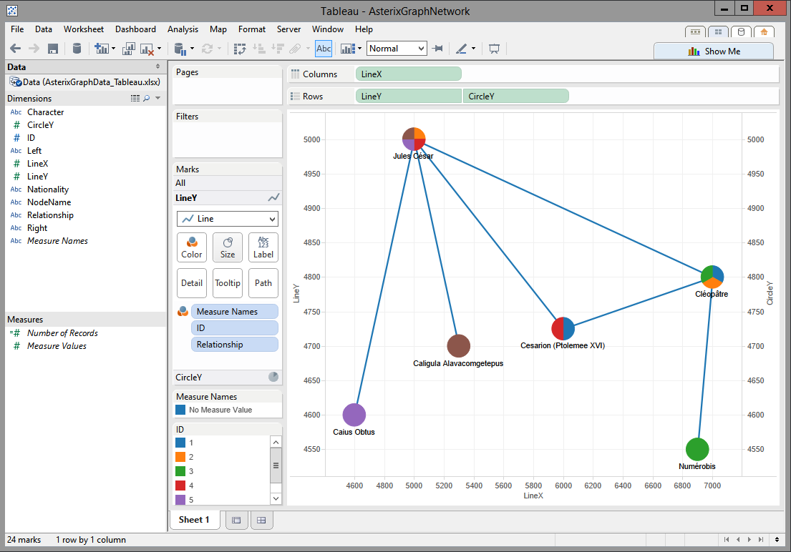](https://stephanefrechette.com/blog/wp-content/uploads/2014/04/tableau_ng_04.png)

To further enhance your visualization you could add a summary table, provide filters, and modify the tooltips.

[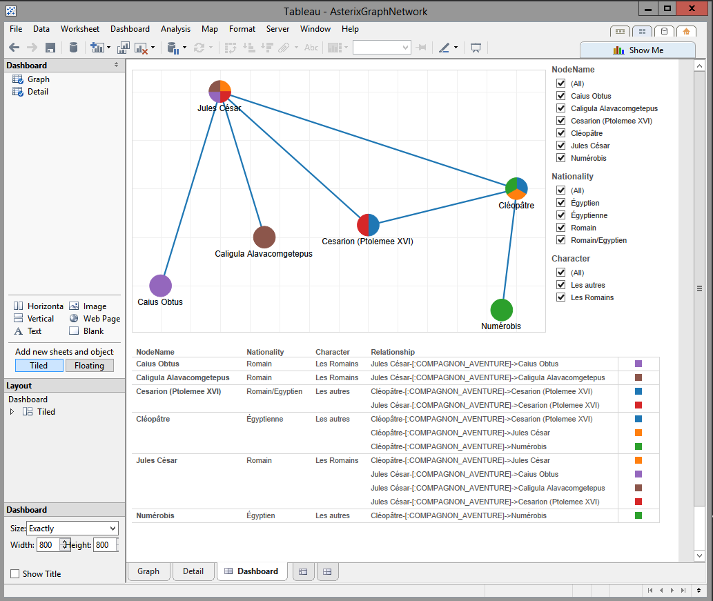](https://stephanefrechette.com/blog/wp-content/uploads/2014/04/tableau_ng_05.png)

Have fun!